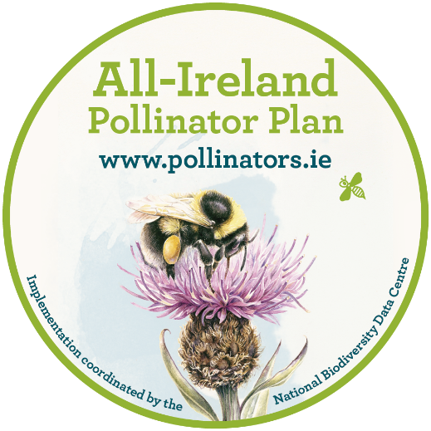

All-Ireland Pollinator Plan 2026-2030
Supporter agreement

We all depend on pollinators and the important service they provide. Unfortunately, our pollinators are in decline. There are over 100 different types of bees on the island of Ireland, and almost one third are threatened with extinction. The All-Ireland Pollinator Plan is a strategy that addresses this problem. It is a shared plan of action that aims to help pollinators and improve biodiversity across the island. In publishing the All-Ireland Pollinator Plan 2015-2020 and 2021-2025, Ireland became one of the first countries to a develop a pollinator strategy. Thanks to the support of sectors throughout the island, we are now recognised as a world leader in pollinator conservation. It is hoped that we can build on the great work that has already been achieved and make the 2026-2030 Plan even more successful.
To sign up as a supporter of the All-Ireland Pollinator Plan 2026-2030, please complete this signed framework and return to: pollinators@biodiversityireland.ie
In becoming a supporter of the AIPP 2026-2030, you agree to:
- Support the ethos of the AIPP and its aim to make the island more pollinator friendly.

- Provide a short update (max 300 words) on your activities to support the Plan, if requested, at the end of each year. This will be used to show progress and to help with knowledge exchange across sectors.

- Where relevant, to log your actions on the online mapping system ‘Actions for Pollinators’ at https://pollinators.biodiversityireland.ie

Please tick any other actions that you are willing to agree to:
Possible actions
Promote the All-Ireland Pollinator Plan to your own networks, where relevant
Manage your site(s) in a pollinator-friendly way in line with the AIPP guidelines
Monitor the impact of your pollinator-friendly actions by taking part in one of the associated citizen science monitoring schemes: Bumblebee Monitoring Scheme; Flower Insect Timed Counts.
Offer technical or expert support/advice to the AIPP where relevant
Other actions - you may have other specific actions that you would like to agree to, and we are very grateful where this is the case. Please list these here:

Organisation: _________________________________________________
Signature: _________________________________________________
Print name: _________________________________________________
Role: _________________________________________________
Email point of contact: _________________________________________________

☐ By ticking this box, you are agreeing that the National Biodiversity Data Centre can store your information and contact you when necessary, regarding the All-Ireland Pollinator Plan. Your organisation name will be added to the list of supporters on the All-Ireland Pollinator Plan website (pollinators.ie). Your name and email address will not be made public.
The National Biodiversity Data Centre collects and processes personal data as legislated in the General Data Protection Regulation (GDPR) (EU) 2016/679. Your name and email address will not be shared with third parties or used for any other purpose than to contact you as an AIPP supporter, where necessary within the All-Ireland Pollinator Plan.
For full details on The National Biodiversity Data Centre Privacy Policy visit https://biodiversityireland.ie/privacy-policy/

