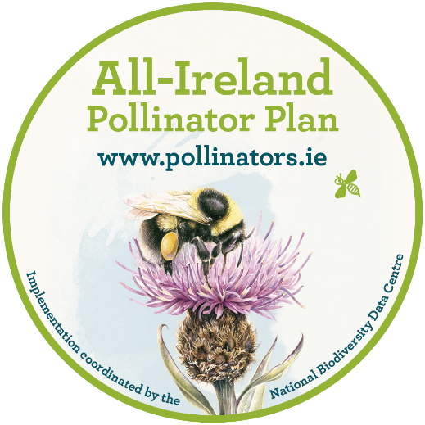

All-Ireland Pollinator Plan 2021-2025
Supporter agreement

We all depend on pollinators and the important service they provide. Unfortunately, our pollinators are in decline. Of the 99 different types of bees on the island of Ireland, almost one third are threatened with extinction. The All-Ireland Pollinator Plan is a strategy that addresses this problem. It is a shared plan of action that aims to help pollinators and improve biodiversity across the island. In publishing the All-Ireland Pollinator Plan 2015-2020, Ireland became one of the first countries to a develop a pollinator strategy. Thanks to the buy-in across sectors throughout the island, we are now recognised as a world leader. It is hoped that we can refocus and come together again to build on what we have already achieved and make the 2021-2025 Plan even more successful.
To sign up as a supporter of the All-Ireland Pollinator Plan 2021-2025, please complete this signed framework and return to: pollinators@biodiversityireland.ie
In becoming a supporter of the AIPP 2021-2025, you agree to:
- Support the ethos of the AIPP and its aim to make the island more pollinator friendly.

- Provide a short update (max 300 words) on your activities to support the Plan, if requested, in November each year. This will be used to show progress and to help with knowledge exchange across sectors.

- Where relevant, to log your actions on the online mapping system ‘Actions for Pollinators’ at https://pollinators.biodiversityireland.ie

Please tick any other actions that you are willing to agree to:
Possible actions
Promote the All-Ireland Pollinator Plan to your own networks, where relevant
Manage your site(s) in a pollinator-friendly way in line with the AIPP guidelines
Monitor the impact of your pollinator-friendly actions by taking part in one of the associated citizen science monitoring schemes: Bumblebee Monitoring Scheme; Flower Insect Timed Counts.
Offer technical or expert support/advice to the AIPP where relevant
Other actions - you may have other specific actions that you would like to agree to, and we are very grateful where this is the case. Please list these here:

Organisation: _________________________________________________
Signature: _________________________________________________
Print name: _________________________________________________
Role: _________________________________________________
Email point of contact: _________________________________________________

The AIPP is a voluntary Plan and is not policed. It does not have a project budget. Organisations agree to fund their own pollinator activities.

