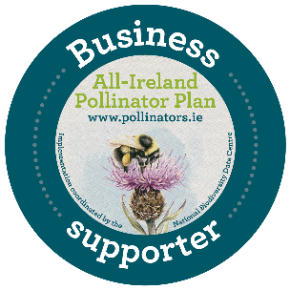
Supporting the Pollinator Plan:
Framework for Businesses

Ireland, North and South, depends on pollinators and the important service they provide. Unfortunately, our pollinators are in decline. Of the 99 different types of bees on the island of Ireland, nearly one third are threatened with extinction. The All-Ireland Pollinator Plan is a strategy that addresses this problem. It is a shared plan of action supported by more than 100 governmental and non-governmental organisations. By helping our pollinators, we are improving biodiversity across Ireland.
Now we are asking businesses across the island to support the All-Ireland Pollinator Plan. All companies, regardless of their sector, size, or and holdings, can play a role in helping pollinators.
If you would like to sign up as a Business Supporter of the Plan, email us a copy of this page signed by a member of senior management. In doing so, your organisation agrees:
- To carry out at least one pollinator friendly action suggested in guideline document within the first year of signing up, and to plan to carry out two additional actions within the following five years.
- To update the Pollinator Plan Team on the positive pollinator actions you have planned, implemented, or maintained each year when contacted, to help us promote your work.
- That your business supports the ethos of the Pollinator Plan
- Once you have signed up, please send us a copy of your logo. We will only use your logo to promote your pollinator friendly work in the following three ways: on the Partners Page of our website, on our blog and in our annual report. In return you will receive a copy of the Pollinator Plan's Business Support logo, for use in CSR/sustainability reports and on blogs/case studies.

Along with the business benefits that come from supporting the Pollinator Plan, companies that sign up will receive a certificate of participation. You will also receive our support in developing your plans to take pollinator friendly actions within your business.
We look forward to working with you to ensure that our pollinators and the critical service of pollination are available for generations to come.
Business Name: ______________________________________________

Senior Management Signature: _________________________________

Print (name and job title): ______________________________________

Point of contact (if different from above): _________________________

Email: ufitzpatrick@biodiversityireland.ie. Postal address: The National Biodiversity Data Centre, Beechfield House, Carriganore. Waterford. Additional use of the Pollinator Plan business support logo requires written approval. Currently our capacity to provide support includes consultations over the phone or by email.

